pig -x local

grunt> lines = LOAD 'sqoop.txt' AS (line:chararray);



grunt> words = FOREACH lines GENERATE FLATTEN(TOKENIZE(line)) as word;



grunt> DUMP words

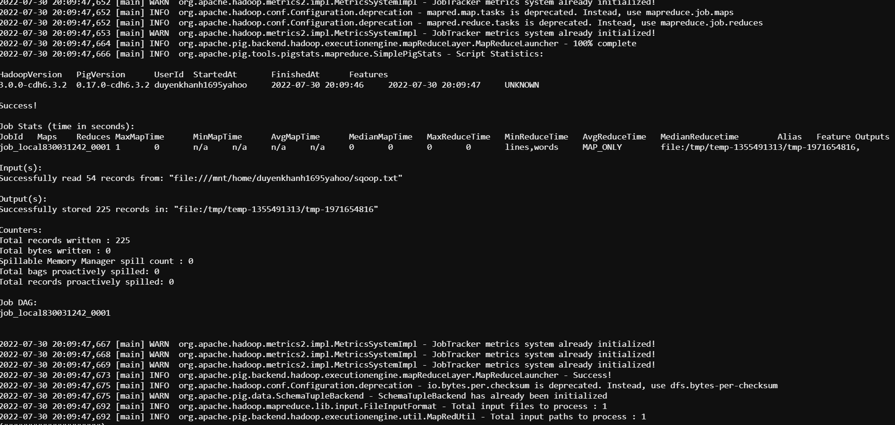

grunt> grouped_words = GROUP words BY word;

grunt> DUMP grouped_words

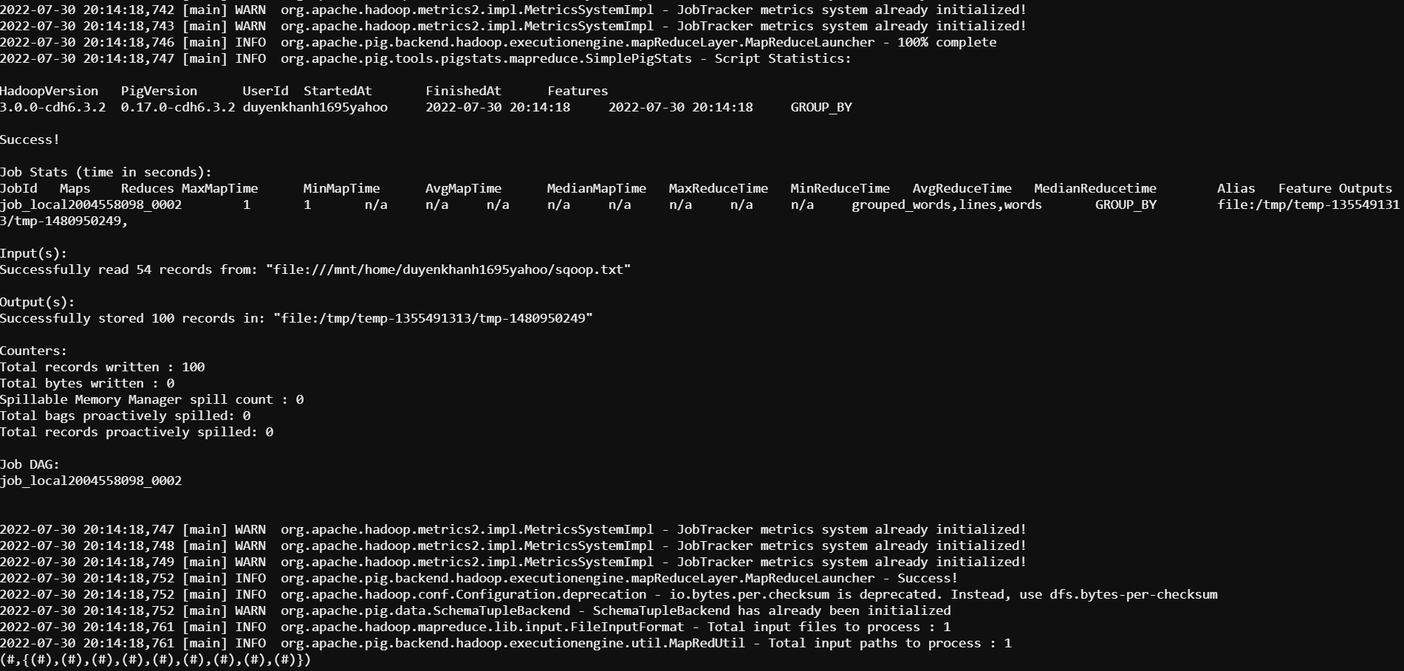

grunt> wordcount = FOREACH grouped_words GENERATE group, COUNT(words);

grunt> DUMP wordcount

